Algebra 2 Unit 2A Review Name: _____________________ Period: _____

Given the following equations, provide all information and graph the function.
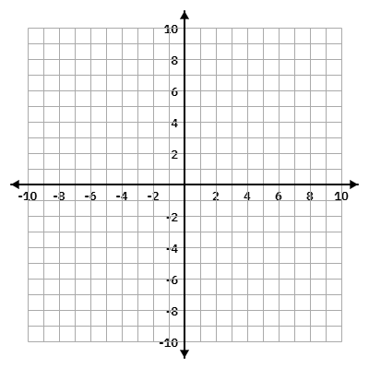
1. Equation: $f(x)= 5|x+1|-9$
Domain (interval): _____________ Range (interval): ______________

x-intercept(s):__________________ Y-intercept: ___________________

Vertex: _______________ Axis of Symmetry: _____________

Max: ___________ OR Min: ___________

Function Notation Description: _______________

Verbal Description:


2. Equation: $f(x)= -2|x-3|+6$
Domain (interval): _____________ Range (interval): ______________

x-intercept(s):__________________ Y-intercept: ___________________

Vertex: _______________ Axis of Symmetry: _____________

Max: ___________ OR Min: ___________

Function Notation Description: _______________

Verbal Description:


3. Equation: $f(x)= -\frac{1}{2}|x-4|+3$
Domain (interval): _____________ Range (interval): ______________

x-intercept(s):__________________ Y-intercept: ___________________

Vertex: _______________ Axis of Symmetry: _____________

Max: ___________ OR Min: ___________

Function Notation Description: _______________

Verbal Description:


4. Equation: $f(x)= 3|x+2|-3$
Domain (interval): _____________ Range (interval): ______________

x-intercept(s):__________________ Y-intercept: ___________________

Vertex: _______________ Axis of Symmetry: _____________

Max: ___________ OR Min: ___________

Function Notation Description: _______________

Verbal Description:


5. Equation: $f(x)=-\frac{1}{3}\left|x+4\right|-1$
Domain (interval): _____________ Range (interval): ______________

x-intercept(s):__________________ Y-intercept: ___________________

Vertex: _______________ Axis of Symmetry: _____________

Max: ___________ OR Min: ___________

Function Notation Description: _______________

Verbal Description:


6. Equation: $f(x)= -3|x+2|+9$
Domain (interval): _____________ Range (interval): ______________

x-intercept(s):__________________ Y-intercept: ___________________

Vertex: _______________ Axis of Symmetry: _____________

Max: ___________ OR Min: ___________

Function Notation Description: _______________

Verbal Description:

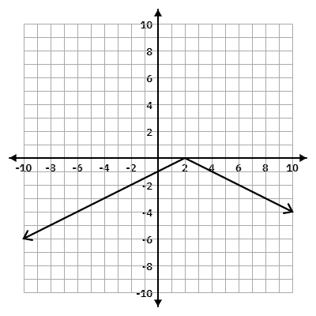
Given the graph, write the equation, and provide all information.
Equation: ___________________________

Domain (interval): _____________ Range (interval): ______________

x-intercept(s):__________________ Y-intercept: ___________________

Vertex: _______________ Axis of Symmetry: _____________

Max: ___________ OR Min: ___________

Function Notation Description: _______________

Verbal Description:

7.

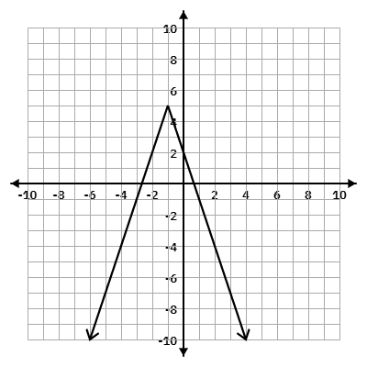
Equation: ___________________________

Domain (interval): _____________ Range (interval): ______________

x-intercept(s):__________________ Y-intercept: ___________________

Vertex: _______________ Axis of Symmetry: _____________

Max: ___________ OR Min: ___________

Function Notation Description: _______________

Verbal Description:

8.

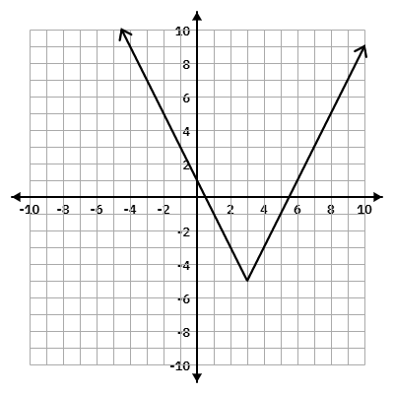
9.
Equation: ___________________________

Domain (interval): _____________ Range (interval): ______________

x-intercept(s):__________________ Y-intercept: ___________________

Vertex: _______________ Axis of Symmetry: _____________

Max: ___________ OR Min: ___________

Function Notation Description: _______________

Verbal Description:

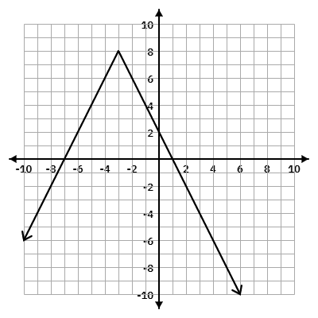
Equation: ___________________________

Domain (interval): _____________ Range (interval): ______________

x-intercept(s):__________________ Y-intercept: ___________________

Vertex: _______________ Axis of Symmetry: _____________

Max: ___________ OR Min: ___________

Function Notation Description: _______________

Verbal Description:

10.

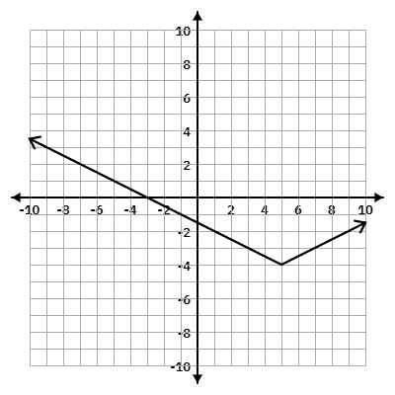
11.
Equation: ___________________________

Domain (interval): _____________ Range (interval): ______________

x-intercept(s):__________________ Y-intercept: ___________________

Vertex: _______________ Axis of Symmetry: _____________

Max: ___________ OR Min: ___________

Function Notation Description: _______________

Verbal Description:

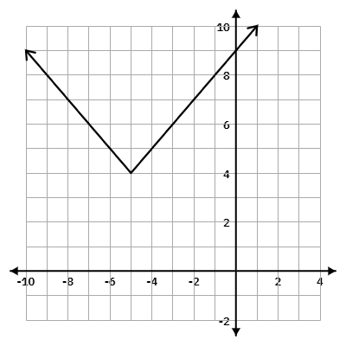
12.
Equation: ___________________________

Domain (interval): _____________ Range (interval): ______________

x-intercept(s):__________________ Y-intercept: ___________________

Vertex: _______________ Axis of Symmetry: _____________

Max: ___________ OR Min: ___________

Function Notation Description: _______________

Verbal Description:

Given a verbal description, write the equation or other requested information.

13. The function $f(x)=|x|$ is transformed to form a new function $g(x)$, which contains the following: Vertical shift 2 units down, Horizontal shift 3 units to the left

What is the equation for $g(x)$?

14. The function $f(x)=|x|$ is transformed to form a new function $g(x)$, which contains the following: Reflect over x-axis, Vertical shift 4 unit up, Vertical Stretch by 7.

What is the equation for $g(x)$?

15. The function $f(x)=|x|$ is transformed to form a new function $g(x)$, which contains the following: Reflect over y-axis, Vertical shift 6 unit up, Vertical compression by 1/2.

What is the equation for $g(x)$?

16. The function $f(x)=|x|$ is transformed to form a new function $g(x)$, which contains the following: Vertical stretch by 3, Vertical shift 6 units up, Horizontal shift 6 units to the right.

What is the equation for $g(x)$?

17. The function $f(x)=|x|$ is transformed to form a new function $g(x)$, which contains the following: Reflect over x-axis, Vertical compression by 1/3, Vertical shift 1 unit down, Horizontal shift 5 units to the right.

What is the equation for $g(x)$?

18. If an absolute value function as a domain of all real numbers and x-intercepts (-4, 0) and (-2, 0) with a vertical stretch of 2,

What is the vertex?

19. If an absolute value function as a domain of all real numbers and x-intercepts (-4, 0) and (6, 0) with a vertical compression of $\frac{3}{5}$, and a reflection over the x-axis,

What is the vertex?

20. If an absolute value function as a domain of all real numbers and x-intercepts (-4, 0) and (6, 0) with a vertical compression of $\frac{3}{5}$, and a reflection over the x-axis,

What is the vertex?

24.If an absolute value function as a domain of all real numbers and x-intercepts (-1, 0) and
(1, 0) with a vertical stretch of 3, and a reflection over the x-axis,

What is the vertex?

25. If an absolute value function as a domain of all real numbers and x-intercepts (-4, 0) and (0, 0) with a vertical stretch of 4,

What is the vertex?

